INTRODUCTION
Architecturally, JSP may be viewed as a high-level abstraction of Java servlets. JSP pages are loaded in the server and are operated from a structured special installed Java server packet called a Java EE Web Application, often packaged as a .war or .ear file archive.
JSP allows Java code and certain pre-defined actions to be interleaved with static web markup content, with the resulting page being compiled and executed on the server to deliver an HTML or XML document. The compiled pages and any dependent Java libraries use Java bytecode rather than a native software format, and must therefore be executed within a Java virtual machine (JVM) that integrates with the host operating system to provide an abstract platform-neutral environment.
JSP syntax is a fluid mix of two basic content forms: scriptlet elements and markup. Markup is typically standard HTML or XML, while scriptlet elements are delimited blocks of Java code which may be intermixed with the markup. When the page is requested the Java code is executed and its output is added, in situ, with the surrounding markup to create the final page. JSP pages must be compiled to Java bytecode classes before they can be executed, but such compilation is needed only when a change to the source JSP file has occurred.
Java code is not required to be complete (self contained) within its scriptlet element block, but can straddle markup content providing the page as a whole is syntactically correct (for example, any Java if/for/while blocks opened in one scriptlet element must be correctly closed in a later element for the page to successfully compile). This system of split inline coding sections is called step over scripting because it can wrap around the static markup by stepping over it. Markup which falls inside a split block of code is subject to that code, so markup inside an if block will only appear in the output when the if condition evaluates to true; likewise markup inside a loop construct may appear multiple times in the output depending upon how many times the loop body runs.
The JSP syntax adds additional XML-like tags, called JSP actions, to invoke built-in functionality. Additionally, the technology allows for the creation of JSP tag libraries that act as extensions to the standard HTML or XML tags. JVM operated tag libraries provide a platform independent way of extending the capabilities of a web server. Note that not all commercial Java servers are Java EE specification compliant.
MySQL is a relational database management system (RDBMS)^{[2]} that runs as a server providing multi-user access to a number of databases. The SQL phrase stands for Structured Query Language.

The software components used in our project are as under:
- Eclipse
- MySQL database
OVERVIEW
The importace of placement system is increasing day by day. Thousands of applicants are depending placement cell. But the applicants are facing so many problems. This project is an attempt to minimize the problems of an applicant to find a correct job. If we can make it an online computerized and a mobile alert process it will be so fast and convenient for the applicants.Far from upsetting matters, however, new technologies have predominantly made life better and considerably easier for most 0people, and so it must be concluded that they should be welcomed.
Software does not require a dedicated computer and can be run on almost any PC running Windows OS The package includes the MOB JOBS software and a normal cell phone and data cable. It uses a normal SIM card from a GSM operator with a local mobile number. In functionality it is similar to the four digit short codes but unlike short codes that is billed according to the agreement between the content provider and the service provider and can only be reached from certain networks a long code (Local GSM number) can be accessed from almost anywhere in the world for the price of an Normal SMS depending on location and tariff of the Local GSM operator. Receiving the response is an incoming SMS and is free.
EXISTING SYSTEM
The existing system is a manual system of limitations like accuracy, expense, low speed and efficiency and unformatted outputs. In the existing system, all data processing is done manually. All the files and record books are replaced by the software system. When there are a lot of issues such as retrieval and storage of the information and keeping track of them becomes a tedious task. By implementing a computerized system, the limitation in the present system will be reduced. Manpower can be reduced to a great extent and efficiency and accuracy can be increased to manifold. More over consumption of time can be reduced to far greater extend by the implementation of the proposed system.
PROPOSED SYSTEM
In the proposed system we propose to computerize the above-mentioned activities. In the existing system, all data processing is done manually. When there are a lot of issues such as retrieval and storage of the information and keeping track of them becomes a tedious task. By implementing a computerized system, the limitation in the present system will be reduced. Manpower can be reduced to a great extent and efficiency and accuracy can be increased to manifold. More over consumption of time can be reduced to far greater extend by the implementation of the proposed system.
The proposed computer based information system is aimed at eliminating the limitations of the existing system via increasing speed of information retrieval, by increasing processing speed, data security and hence give accurate reports. The proposed system fully satisfies user needs. All most all the limitations of the existing system are reduced in a great manner. Details are stored in various files from which data can be accessed and manipulated easily.
In the proposed system there are two sections one is administration part in which the following processes are carried out.

MERITS OF PROPOSED SYSTEM
- A lot of manual work which is time consuming and tedious can be reduced.
- Eliminates wrong entries and hence give accurate report.
- Reduce paper work and extra cost.
- Data redundancy can be avoided.
- Data security.
- Information retrieval is faster.
- User friendliness.
- Flexibility.
- The number of registers can be reduced.
- The new system provides data consistency and integrity so that data at any time represent the current status.
- The system should provide better security and control over data.

MODULE DESCRIPTION
1). Applicant registration
2). Company registration
3). Job search
4). Vacancy Registration
5). Message

1) Applicant registration:
The applicant can register into the site by providing his details and he can set his username and password for logging in later.

2) Company registration:
The authority of the company can register into the site by providing its details and they can set its username and password for logging in. They can also specify their requirements for each vacancy.

3) Job search:
Applicants can search for the job vacancies in the fields of their choice and apply as interested.

4) Vacancy registration:
Authority of the company can provide all the necessary information about the vacancies in each post along with eligibility criteria.

5) Message:
Software selects the apt ones from the registered applicants for each post and informs them by a mobile alert. The message includes interview details.

SYSTEM SPECIFICATION

HARDWARE REQUIREMENTS

Minimum Requirements
Processors : Intel Pentium Pro or Processor running at 133 MHz
Hard Disk : 1.2 GB Hard Disk
RAM : Client Level – Minimum 128MB
Recommended Requirements for peek performance
Processors : Intel Pentium III running at 450 MHz
RAM : Client Level – Minimum 512MB
Display Type: SVGA Color Monitor
Keyboard : Enhanced 104 Standard
Mouse : PS/2 2 Button

SOFTWARE REQUIREMENTS

Operating System : WINDOWS 2000/2003/
XP/WINDOWS 7/WINDOWS VISTA
TOOLS USED:
Front end: ECLIPSE
Back end: MYSQL ,TOMCAT SERVER

E-R DIAGRAM

TABLE STRUCTURES
The structure of all tables included in the project is as under:-
1.INTERVIEW
+-----------+-------------+------+-----+---------+-------+
| Field | Type | Null | Key | Default | Extra |
+-----------+-------------+------+-----+---------+-------+
| can_uname | varchar(50) | YES | MUL | NULL | |
| com_name | varchar(50) | YES | MUL | NULL | |
| iv_date | date | YES | | NULL | |
| iv_time | varchar(20) | YES | | NULL | |
| iv_place | varchar(50) | YES | | NULL | |
+-----------+-------------+------+-----+---------+-------+
2.EMPLOYER
+----------+-------------+------+-----+---------+-------+
| Field | Type | Null | Key | Default | Extra |
+----------+-------------+------+-----+---------+-------+
| emp_name | varchar(50) | NO | PRI | | |
| emp_pass | varchar(50) | YES | | NULL | |
| emp_web | varchar(50) | YES | | NULL | |
+----------+-------------+------+-----+---------+-------+

3.APPLICANT
+----------+-------------+------+-----+---------+-------+
| Field | Type | Null | Key | Default | Extra |
+----------+-------------+------+-----+---------+-------+
| fname | varchar(50) | NO | | NULL | |
| lname | varchar(50) | NO | | NULL | |
| gender | varchar(10) | NO | | NULL | |
| username | varchar(50) | NO | PRI | NULL | |
| password | varchar(50) | NO | | NULL | |
| email | varchar(50) | NO | | NULL | |
+----------+-------------+------+-----+---------+-------+
4.JOB
mysql> desc job;
+----------+-------------+------+-----+---------+-------+
| Field | Type | Null | Key | Default | Extra |
+----------+-------------+------+-----+---------+-------+
| c_name | varchar(50) | NO | PRI | | |
| c_web | varchar(50) | YES | | NULL | |
| vacancy | int(50) | YES | | NULL | |
| salary | int(50) | YES | | NULL | |
| job_desc | varchar(50) | YES | | NULL | |
| location | varchar(50) | YES | | NULL | |
| sel_post | varchar(50) | YES | | NULL | |
| iv_date | date | YES | | NULL | |
| iv_time | varchar(20) | YES | | NULL | |
| iv_place | varchar(50) | YES | | NULL | |
+----------+-------------+------+-----+---------+-------+
SOURCE CODE
PAGE:home1.jsp

<%@ page language="java" contentType="text/html; charset=ISO-8859-1"
pageEncoding="ISO-8859-1"%>
<!DOCTYPE html PUBLIC "-//W3C//DTD HTML 4.01 Transitional//EN" "http://www.w3.org/TR/html4/loose.dtd">
<html>
<head>
<meta http-equiv="Content-Type" content="text/html; ">
<title>Getjobs.com1 </title>
</head>
<MARQUEE behavior=alternate BGCOLOR="WHITE" TEXT="WHITE"><BLINK BGCOLOR="BLUE"><B><I><H1 ><p style="font-family:calibri;color:blue;font-size:45px;" >INFOSYS,HP,COGNIZANT,TRAVISCA,DEOLITE and MANY MORE</p></H1></I></B></BLINK></MARQUEE>
<BODY bgcolor="#ffffff" background="a.jpg">

<center><br><br>
<FONT FACE="COPPERPLATE GOTHIC BOLD" SIZE="5" COLOR="BLUE">GETJOBS.COM</center><br><center>
<table BORDER=10 WIDTH=200 HEIGHT=150 BGCOLOR="WHITE" >

<tr>

<td ALIGN=CENTER VALIGN=MIDDLE><A HREF="LOGIN_A.jsp" value=home><STRONG><p style="font-family:arial;color:blue;font-size:40px;">APPLICANT LOGIN</p></STRONG></A></td>
</tr>
<tr>
<td ALIGN=CENTER VALIGN=MIDDLE><A HREF="login_e.jsp" value=about ><STRONG>EMPLOYER LOGIN</STRONG></A></td>
</tr>

</table>
<script language="Javascript">
function linksomepage_onclick()
{
alert("REGISTER FIRST IF NEW USER OR SIGNIN");
return true;
}
</script><br><br><span style="padding-left:0px"><img src="1.gif" width="100" height="100" align = left span style="padding-left:30px">
<br>
<table>
<tr>
<td>
<font color="blue" face="impact" size="2"> <a href="" name="linkSomepage" onclick="return linksomepage_onclick()">Advertising/PR</a><br>
<td>
<font color="blue" face="impact" size="2"><a href="" name="linkSomepage" onclick="return linksomepage_onclick()">Arts/Entertainment/<br>Publishing</a><br>
<tr>
<td>
<font color="blue" face="impact" size="2"><a href="" name="linkSomepage" onclick="return linksomepage_onclick()">College</a><br>
<td>
<font color="blue" face="impact" size="2"><a href="" name="linkSomepage" onclick="return linksomepage_onclick()">Education/Training</a><br>
<td>
<font color="blue" face="impact" size="2"><a href="" name="linkSomepage" onclick="return linksomepage_onclick()">Engineering/Architecture</a><br>
<tr>
<td>
<font color="blue" face="impact" size="2"> <a href="" name="linkSomepage" onclick="return linksomepage_onclick()">Entrepreneurial/Start-up</a><br>
<td>
<font color="blue" face="impact" size="2"><a href="" name="linkSomepage" onclick="return linksomepage_onclick()">Entry Level</a><br>
<td>
<font color="blue" face="impact" size="2"><a href="" name="linkSomepage" onclick="return linksomepage_onclick()">Government</a><br>
<tr>
<td>
<font color="blue" face="impact" size="2"><a href="" name="linkSomepage" onclick="return linksomepage_onclick()">Health Care</a><br>
<td>
<font color="blue" face="impact" size="2"><a href="" name="linkSomepage" onclick="return linksomepage_onclick()">Hospitality/Travel</a><br>
<td>
<font color="blue" face="impact" size="2"><a href="" name="linkSomepage" onclick="return linksomepage_onclick()">Human Resources</a><br>
<tr>
<td>
<font color="blue" face="impact" size="2"><a href="" name="linkSomepage" onclick="return linksomepage_onclick()">Insurance</a><br>
<td>

<td>
<font color="blue" face="impact" size="2"> <a href="" name="linkSomepage" onclick="return linksomepage_onclick()">Internet/New Media</a><br>
<tr>
<td>
<font color="blue" face="impact" size="2"><a href="" name="linkSomepage" onclick="return linksomepage_onclick()">Legal</a><br>
<td>
<font color="blue" face="impact" size="2"><a href="" name="linkSomepage" onclick="return linksomepage_onclick()">Manufacturing/Operations</a><br>
<td>
<tr>
<td>
<font color="blue" face="impact" size="2"><a href="" name="linkSomepage" onclick="return linksomepage_onclick()">Marketing</a><br>

<td>
<font color="blue" face="impact" size="2"><a href="" name="linkSomepage" onclick="return linksomepage_onclick()">Pharmaceutical/Biotech</a><br>

<td>
<font color="blue" face="impact" size="2"><a href="" name="linkSomepage" onclick="return linksomepage_onclick()">Real Estate/Construction/<br>Facilities</a><br>
<tr>
<td><font color="blue" face="impact" size="2"><a href="" name="linkSomepage" onclick="return linksomepage_onclick()">Retail</a><br>
<td>
<font color="blue" face="impact" size="2"><a href="" name="linkSomepage" onclick="return linksomepage_onclick()">Sales</a><br>
<td>
<font color="blue" face="impact" size="2"><a href="" name="linkSomepage" onclick="return linksomepage_onclick()">Tech Contract</a><br>

<tr>
<td><font color="blue" face="impact" size="2"><a href="" name="linkSomepage" onclick="return linksomepage_onclick()">Technology</a><br>

<td><font color="blue" face="impact" size="2"><a href="" name="linkSomepage" onclick="return linksomepage_onclick()">Telecommunications</a><br>
<td>
<font color="blue" face="impact" size="2"><a href="" name="linkSomepage" onclick="return linksomepage_onclick()">Temp Jobs</a><br>
</table>
<br><br>
<center><font face="impact" size="1" color="black">GETJOBS.COM is a registered organization</font> </center>

</body>
</html>

PAGE: login_a.jsp
<%@ page language="java" contentType="text/html; charset=ISO-8859-1"
pageEncoding="ISO-8859-1" import="java.sql.*"%>
<!DOCTYPE html PUBLIC "-//W3C//DTD HTML 4.01 Transitional//EN" "http://www.w3.org/TR/html4/loose.dtd">
<html>
<head>
<meta http-equiv="Content-Type" content="text/html; charset=ISO-8859-1">
<title>Insert title here</title>
<script type="text/javascript" language="javascript">
function chk_onclick()
{
var myform=document.pform;
if(myform.username.value=="" || myform.passwd.value=="")
{
alert("PLEASE COMPLETE ALL THE SPECIFICATION");
if(myform.username.value=="")
{
myform.username.focus();
}
else
{
myform.passwd.focus();
}
}

}
</script>
</head>
<body background="c.jpg">
<font face="verdana,arial" size=-1>
<center><table cellpadding=2 cellspacing=0 border=0 height=500 width=600>

<tr><td bgcolor="blue"><B>APPLICANT'S LOGIN</B>
<table cellpadding=0 cellspacing=0 border=0 width=100%><tr>
<img src="login-icon.gif" width="100" height="100">
<td bgcolor="blue" align=center style="padding:2;padding-bottom:4">

<b><font size=-1 color="white"
face="verdana,arial"><b>Enter your login and password</b></font></td></tr>
<tr><td bgcolor="white" style="padding:5"><br>

<form method="post" action="LOGIN_A.jsp" name=pform>

<center><table>
<tr><td><font face="verdana,arial" size=-1>USERNAME:</td><td>
<input type="text" name="username"></td></tr>
<tr><td><font face="verdana,arial" size=-1>PASSWORD:</td><td>
<input type="password" name="passwd"></td></tr>
<tr><td><font face="verdana,arial" size=-1>&nbsp;
</td><td><font face="verdana,arial" size=-1>
<input type="submit" value="SUBMIT" name=chkform onclick="chk_onclick()"></td></tr>
<tr><td colspan=2><font face="verdana,arial" size=-1>&nbsp;</td></tr>

<tr><td colspan=2><font face="verdana,arial" size=-1>Not member yet? Click <a

href="1.jsp">here</a> to register.</td></tr>
<td align="right" valign="bottom"><img src="1.gif" width="5" height="5" ></td>
</table></center>
</form>
</td></tr></table></td></tr></table>
</body>
</html>
<%

String k1=request.getParameter("username");
session.setAttribute("t1",k1);
if(k1!=null){
try{
//int flag=2;
//String k1=request.getParameter("username");
String k2=request.getParameter("passwd");
Class.forName("sun.jdbc.odbc.JdbcOdbcDriver");
Connection c=DriverManager.getConnection("jdbc:odbc:abc","root","root");
Statement s =c.createStatement();
String sql = "select * from applicant where username='"+k1+"'";// and password='"+k2+"'";
ResultSet rs=s.executeQuery(sql);
rs.next();
String pass=rs.getString(5);

if(k2.equals(pass))
{
%>
<jsp:forward page="app_home.jsp" />
<%}
else
{
%><script type="text/javascript" language="javascript">
alert("Your ID and Password do not match.Enter a valid Login Id and Password.");
</script>
<%}

}catch(Exception e)
{
%><script type="text/javascript" language="javascript">
alert("INVALID USER ID");
</script>
<%}
}
%>

PAGE: app_home.jsp
<%@ page language="java" contentType="text/html; charset=ISO-8859-1"
pageEncoding="ISO-8859-1" import = "java.sql.*"%>
<!DOCTYPE HTML PUBLIC "-//W3C//DTD HTML 4.01 Transitional//EN" "http://www.w3c.org/TR/1999/REC-html401-19991224/loose.dtd">
<HTML><HEAD><FONT SIZE="4"COLOR="blue" FACE="roman">CANDIDATE HOME PAGE
</FONT><br>
<FONT SIZE="4"COLOR="blue" FACE="roman">WELCOME
<%=session.getAttribute("t1") %></FONT>
<TITLE>APPLICANT HOME PAGE</TITLE>
<META content="text/html; charset=windows-1252" http-equiv=Content-Type>
<META name=GENERATOR content="MSHTML 9.00.8080.16413"></HEAD>
<BODY BGCOLOR="#4EE2EC" >
<form NAME="CREATEACCTFORM" action="app_home.jsp" METHOD="POST" >
<table width="780" border="0" align="center" cellpadding="0" cellspacing="0">
<table width="100%" border="0" cellpadding="7" cellspacing="0" class="bg_white">
<tr>
<td width="400" align="right" bgcolor="#736AFF">Search Jobs</td>
</tr>
<tr>
<table border="0" align="center" cellpadding="0" cellspacing="0">
<tr>
<span id="email_msg">
</span>
</tr>

</table>

<div id="EMAILID" style="width:250px; margin-left:205px; margin-top:-20px; _margin-left:20px; _margin-top:0px; position:absolute;"></div>
<div id="ERR_EMAIL" style="padding: 2px; width: 400px; display: none;" class="txt_red small_1"></div>
</td>

</tr>

<tr>
<td align="right" valign="top">Location: </td>

<td valign="top" >

<select name="loc" style="width:165" ><option > - Select -</option><option >DELHI</option><option>BANGLORE</option><option>CHENNAI</option><option>GURGAON</option><option>HYDERABAD</option><option>MUMBAI</option><option>KOLKATA</option><option>PUNE</option><option>NOIDA</option><option>KANPUR</option></select>

<br>

</tr>

<tr>
<td align="right" valign="top"><span class="txt_orange"></span> Skills:&nbsp</td>
<td valign="top" ><select name="SKILLS" style="width:165" ><option > - Select - </option><option>ITI</option><option>C</option><option>C++</option><option>JAVA</option><option>GOOD TYPING SPEED</option></select>
<br>
<div id="UNAME" style="width:250px; margin-left:205px; margin-top:-20px; _margin-left:20px; _margin-top:0px; position:absolute;"></div>

<div id="ERR_UNAME" style="padding: 2px; width: 400px; display: none;" class="txt_red small_1"></div>
</td>

</tr>
<tr>
<td align="right" valign="top"><span class="txt_orange"></span>Functional Area: </td>
<td valign="top" >
<div id="UNAME" style="width:250px; margin-left:205px; margin-top:-20px; _margin-left:20px; _margin-top:0px; position:absolute;"></div>

<div id="ERR_UNAME" style="padding: 2px; width: 400px; display: none;" class="txt_red small_1"></div>
</td>

</tr><tr>
<select name="area" style="width:165" id="industry" ><option> - Select - </option><option>Any</option><option>Automotive</option><option>Banking</option><option >Bio Technology</option><option>Chemicals</option><option>Construction</option><option>Consumer Goods</option><option>Education</option><option>Entertainment</option><option>Insurance</option><option>BPO</option><option>Hardware</option><option>Software</option></select>
<br>
<td align="right" valign="top"><span class="txt_orange"></span> Key Word: </td>
<select name="key" style="width:165" ><option> - Select - </option><option>Sales Executive</option><option>Teacher</option><option>Manager</option><option>Accounting</option><option>Technician</option><option> Software Professional</option><option>Software Tester</option><option>IT Professional</option></select>

<td valign="top" ><br>
<input maxlength="255" size="30" name="userName" type="submit" value="SEARCH" >
<div id="UNAME" style="width:250px; margin-left:205px; margin-top:-20px; _margin-left:20px; _margin-top:0px; position:absolute;"></div>

<div id="ERR_UNAME" style="padding: 2px; width: 400px; display: none;" class="txt_red small_1"></div>
</td>

</tr>
</table>

<%
String s1=request.getParameter("loc");
String s2=request.getParameter("area");
String s3=request.getParameter("key");
session.setAttribute("a1",s1);
session.setAttribute("a2",s2);
session.setAttribute("a3",s3);
if(s1!=null && s2!=null && s3!=null){
try{

//String s1=request.getParameter("loc");
//String s2=request.getParameter("area");
//String s3=request.getParameter("key");
Class.forName("sun.jdbc.odbc.JdbcOdbcDriver");
Connection c=DriverManager.getConnection("jdbc:odbc:abc","root","root");
Statement s =c.createStatement();
String sql = "select * from job where location='"+s1+"' and job_desc='"+s2+"' and sel_post='"+s3+"'";
//out.println(s1);
//out.println(s2);
//out.println(s3);
ResultSet rs=s.executeQuery(sql);
if(rs.next())
{
%>
<jsp:forward page="job-selct.jsp"/>
<%
}
else
{
%><script type="text/javascript" language="javascript">
alert("SORRY,NO SUCH JOB AVAILABLE.");
</script>
<%
}
out.println("success");
}catch(Exception e ){out.println(e);
}
}
%>
</table>
</form>
<form method="post" action="view.jsp">
<input maxlength="255" size="30" value="VIEW APPLICATIONS" type="submit" >
</form>
</body>
</html>

PAGE: interview.jsp

<%@ page language="java" contentType="text/html; charset=ISO-8859-1"
pageEncoding="ISO-8859-1" import="java.sql.*"%>
<!DOCTYPE html PUBLIC "-//W3C//DTD HTML 4.01 Transitional//EN" "http://www.w3.org/TR/html4/loose.dtd">
<html>
<head>
<meta http-equiv="Content-Type" content="text/html; charset=ISO-8859-1">
<title>Insert title here</title>
<script language="javascript" src="cal2.js">
/*
Xin's Popup calendar script- Xin Yang (http://www.yxscripts.com/)
Script featured on/available at http://www.dynamicdrive.com/
This notice must stay intact for use
*/
</script>
<script language="javascript" src="cal_conf2.js"></script>
</head>
<body BGCOLOR="#4EE2EC">
<form action="app_home.jsp" method="post">
<%
try{
String c1=(String)session.getAttribute("t1");
String b1=(String)session.getAttribute("a1");
String b2=(String)session.getAttribute("a2");
String b3=(String)session.getAttribute("a3");
Class.forName("sun.jdbc.odbc.JdbcOdbcDriver");
Connection c=DriverManager.getConnection("jdbc:odbc:abc","root","root");
Statement s =c.createStatement();
String sql ="select * from job where location='"+b1+"' and job_desc='"+b2+"' and sel_post='"+b3+"'";
ResultSet rs=s.executeQuery(sql);
rs.next();
%>
<table BORDER=10 WIDTH=350 HEIGHT=150 BGCOLOR="WHITE" align="center">

<tr>

<td>
<FONT SIZE="4"COLOR="blue" FACE="roman">Username:<%=session.getAttribute("t1") %></FONT><br></td>
<tr><td><FONT SIZE="4"COLOR="blue" FACE="roman">Company:<%out.println(rs.getString(1));%></FONT><br></td></tr>
<tr><td> <FONT SIZE="4"COLOR="blue" FACE="roman">Vacancies:<%out.println(rs.getString(3));%></FONT><br></td></tr>
<tr><td> <FONT SIZE="4"COLOR="blue" FACE="roman">Salary: <%out.println(rs.getString(4));%></FONT><br></td></tr>
<tr><td> <FONT SIZE="4"COLOR="blue" FACE="roman">Job Post: <%out.println(rs.getString(7));%></FONT><br></td></tr>
<tr><td> <FONT SIZE="4"COLOR="blue" FACE="roman">Location: <%out.println(rs.getString(6));%></FONT><br></td></tr>
<tr><td> <FONT SIZE="4"COLOR="blue" FACE="roman">Interview date: <%out.println(rs.getString(8));%></FONT><br></td></tr>
<tr><td> <FONT SIZE="4"COLOR="blue" FACE="roman">Interview Time: <%out.println(rs.getString(9));%></FONT><br></td></tr>
<tr><td> <FONT SIZE="4"COLOR="blue" FACE="roman">Interview Place: <%out.println(rs.getString(10));%></FONT><br></td></tr>
</table>
<%
Statement m =c.createStatement();
String sq1 ="select * from interview where can_uname='"+c1+"' and com_name='"+rs.getString(1)+"'";
ResultSet rs1=m.executeQuery(sq1);
boolean a=rs1.next();
if(a==false)
{
out.println("success1");
out.println(rs.getString(8));
out.println(rs.getString(9));
out.println(rs.getString(10));
Statement p =c.createStatement();
String sq ="insert into interview values('"+c1+"','"+rs.getString(1)+"','"+rs.getString(8)+"','"+rs.getString(9)+"','"+rs.getString(10)+"')";
p.execute(sq);
out.println("success");
}
else if(a==true)
{
%><script type="text/javascript" language="javascript">
alert("YOU HAVE ALREADY REGISTERED FOR THIS COMPANY.");
</script>
<%
}
String m1=request.getParameter("rs.getString(1)");
session.setAttribute("v1",m1);
out.println("success");
}catch(Exception e ){out.println(e);
}

%>
<INPUT type="submit" value="OK" ><BR>
</form>

<form method="post" action="app_home.jsp">
<INPUT type="submit" value="BACK" ><BR>
</form>
</body>
</html>
PAGE: view.jsp

<%@ page language="java" contentType="text/html; charset=ISO-8859-1"
pageEncoding="ISO-8859-1" import="java.sql.*"%>
<!DOCTYPE html PUBLIC "-//W3C//DTD HTML 4.01 Transitional//EN" "http://www.w3.org/TR/html4/loose.dtd">
<html>
<head>
<meta http-equiv="Content-Type" content="text/html; charset=ISO-8859-1">
<title>Insert title here</title>
</head>
<body>
<form method="post" action="app_home.jsp">
<%
try{
String c1=(String)session.getAttribute("t1");
String b1=(String)session.getAttribute("v1");
Class.forName("sun.jdbc.odbc.JdbcOdbcDriver");
Connection c=DriverManager.getConnection("jdbc:odbc:abc","root","root");
Statement s =c.createStatement();
String sql ="select * from interview where can_uname='"+c1+"'";
ResultSet rs=s.executeQuery(sql);
while(rs.next())
{
int i=0;
i=i+1;

%>
<FONT SIZE="4"COLOR="blue" FACE="roman"><b>APPLICATION:</b><%=i%></FONT><br>
<FONT SIZE="4"COLOR="blue" FACE="roman">Username:<%out.println(rs.getString(1));%></FONT><br>
<FONT SIZE="4"COLOR="blue" FACE="roman">Company:<%out.println(rs.getString(2));%></FONT><br>
<FONT SIZE="4"COLOR="blue" FACE="roman">Interview date: <%out.println(rs.getString(3));%></FONT><br>
<FONT SIZE="4"COLOR="blue" FACE="roman">Interview Time: <%out.println(rs.getString(4));%></FONT><br>
<FONT SIZE="4"COLOR="blue" FACE="roman">Interview Place: <%out.println(rs.getString(5));%></FONT><br>

<%
}

}catch(Exception e ){out.println(e);
}
%>
<input type="submit" value="OK">
</form>
</body>
</html>

PAGE: job_select.jsp

<%@ page language="java" contentType="text/html; charset=ISO-8859-1"
pageEncoding="ISO-8859-1" import="java.sql.*"%>
<!DOCTYPE html PUBLIC "-//W3C//DTD HTML 4.01 Transitional//EN" "http://www.w3.org/TR/html4/loose.dtd">
<html>
<head>
<meta http-equiv="Content-Type" content="text/html; charset=ISO-8859-1">
<title>SELECT JOB</title>
</head>
<body BGCOLOR="#4EE2EC" >
<form method="post" action="interview.jsp">
<%
try{
String b1=(String)session.getAttribute("a1");
String b2=(String)session.getAttribute("a2");
String b3=(String)session.getAttribute("a3");
//out.println(b1);
Class.forName("sun.jdbc.odbc.JdbcOdbcDriver");
Connection c=DriverManager.getConnection("jdbc:odbc:abc","root","root");
Statement s =c.createStatement();
String sql ="select * from job where location='"+b1+"' and job_desc='"+b2+"' and sel_post='"+b3+"'";
ResultSet rs=s.executeQuery(sql);
rs.next();
%><table BORDER=10 WIDTH=200 HEIGHT=150 BGCOLOR="WHITE" align="center">

<tr>

<td><FONT SIZE="4"COLOR="blue" FACE="roman">Company:<%out.println(rs.getString(1));%></FONT><br></td></tr>
<tr>
<td><FONT SIZE="4"COLOR="blue" FACE="roman">Vacancies:<%out.println(rs.getString(3));%></FONT><br>
</td></tr>
<tr><td><FONT SIZE="4"COLOR="blue" FACE="roman">Salary: <%out.println(rs.getString(4));%></FONT><br></td></tr>
<tr><td><FONT SIZE="4"COLOR="blue" FACE="roman">Job Post: <%out.println(rs.getString(7));%></FONT><br></td></tr>
<tr><td><FONT SIZE="4"COLOR="blue" FACE="roman">Location: <%out.println(rs.getString(6));%></FONT><br></td></tr>

</table>
<INPUT type="submit" value="APPLY" align="center">
<%
}catch(Exception e ){out.println(e);
}

%>
</form>
<form method="post" action="app_home.jsp">
<INPUT type="submit" value="BACK" ><BR>

</form>
</body>
</html>
PAGE: 1.jsp

<%@ page language="java" contentType="text/html; charset=ISO-8859-1"
pageEncoding="ISO-8859-1" import = "java.sql.*"%>
<!DOCTYPE HTML PUBLIC "-//W3C//DTD HTML 4.01 Transitional//EN" "http://www.w3c.org/TR/1999/REC-html401-19991224/loose.dtd">
<HTML><HEAD><FONT SIZE="4"COLOR="blue" FACE="roman">Candidate Information Page :
</FONT>

<TITLE>APPLICANT LOGIN PAGE</TITLE>
<META content="text/html; charset=windows-1252" http-equiv=Content-Type>
<META name=GENERATOR content="MSHTML 9.00.8080.16413"></HEAD>
<BODY BGCOLOR="#4EE2EC" >
<form NAME="CREATEACCTFORM" action="1.jsp" METHOD="POST" >
<table width="780" border="0" align="center" cellpadding="0" cellspacing="0">

<table width="100%" border="0" cellpadding="7" cellspacing="0" class="bg_white">

<tr>
<td colspan="2" align="right" valign="top" class="border_green_btm bg_grey" style="padding:0px 10px 0px 0px;"><span class="txt_orange">*</span> Required fields</td>

</tr>

<tr>
<td width="400" align="right" bgcolor="#736AFF">Login Information</td>

</tr>

<tr>
<td align="right" valign="top"><span class="txt_orange">*</span> Email address:</td>

<td valign="top" >
<input type="text" maxlength="255" size="30" id="email" name="email" onFocus="hintEvent('EMAILID');" onBlur="hintEvent('EMAILID', 'HIDE'); showEmail(); " value="">

<table border="0" align="center" cellpadding="0" cellspacing="0">
<tr>

<span id="email_msg">

</span>

</tr>

</table>

<div id="EMAILID" style="width:250px; margin-left:205px; margin-top:-20px; _margin-left:20px; _margin-top:0px; position:absolute;"></div>
<div id="ERR_EMAIL" style="padding: 2px; width: 400px; display: none;" class="txt_red small_1"></div>
</td>

</tr>
<tr>
<td align="right" valign="top"><span class="txt_orange">*</span> First name:</td>

<td valign="top" >
<input maxlength="50" size="30" name="firstName" type="text" onFocus="hintEvent('FNAME');" onBlur="hintEvent('FNAME', 'HIDE');" value="">&nbsp;&nbsp;
<div id="FNAME" style="width:170px; margin-left:200px; margin-top:-20px; _margin-left:5px; _margin-top:0px; position:absolute;"></div>
<div id="ERR_FNAME" style="padding: 2px; width: 400px; display: none;" class="txt_red small_1"></div>

</td>
</tr>

<tr>
<td align="right" valign="top">Last name: </td>

<td valign="top" >
<input maxlength="24" size="30" name="lastName" type="text" value="">
</tr>

<tr>
<td align="right" valign="top"><span class="txt_orange">*</span> Desired username:</td>
<td valign="top" ><input maxlength="255" size="30" name="userName" onFocus="hintEvent('UNAME');" onblur="hintEvent('UNAME', 'HIDE');" type="text" value="">
<div id="UNAME" style="width:250px; margin-left:205px; margin-top:-20px; _margin-left:20px; _margin-top:0px; position:absolute;"></div>

<div id="ERR_UNAME" style="padding: 2px; width: 400px; display: none;" class="txt_red small_1"></div>
</td>

</tr>
<tr>

<td align="right" valign="top"><span class="txt_orange">*</span> Choose a password: </td>
<td valign="top" >
<input maxlength="32" size="30" name="passwd" type="password" value="">

<div id="PASS" style="width:250px; margin-left:205px; margin-top:-20px; _margin-left:20px; _margin-top:0px; position:absolute;"></div>

<div id="ERR_PASS" style="padding: 2px; width: 400px; display: none;" class="txt_red small_1"></div>
</td>
</tr>
<tr>
<td align="right" valign="top"><span class="txt_orange">*</span> Re-enter password: </td>
<td valign="top" >

<input name="passwd_temp" size="30" maxlength="32" type="password" value="">

<div id="PASS_TEMP" style="width:250px; margin-left:205px; margin-top:-20px; _margin-left:20px; _margin-top:0px; position:absolute;"></div>
<div id="ERR_PASS_TEMP" style="padding: 2px; width: 400px; display: none;" class="txt_red small_1"></div>
</td>

</tr>
<tr>
<td colspan="2" align="right" valign="top" style="background:url(http://media.monsterindia.com/v2.1/dots.gif) repeat-x; padding:0px;"><img src="http://media.monsterindia.com/v2.1/trans.gif" width="1" height="1" /></td>
</tr>
<tr>

<td width="400" align="right" bgcolor="#736AFF">Personal Details </td>
<td >&nbsp;</td>
</tr>

<tr>
<td align="right"><span class="txt_orange">*</span> Gender:</td>

<td >
<table cellspacing="0" cellpadding="0" border="0" id="gender_border">
<tr><td>
<input name="gender" type="radio" value="m" onFocus="hintEvent('GENDER1');" onBlur="hintEvent('GENDER1', 'HIDE');">
Male&nbsp;&nbsp;&nbsp;
<input name="gender" type="radio" value="f" onFocus="hintEvent('GENDER1');" onBlur="hintEvent('GENDER1', 'HIDE');">

Female </td>

</tr>
</table>
<div id="GENDER1" style="width:250px; margin-left:250px; margin-top:-60px; _margin-left:20px; _margin-top:0px; position:absolute;"></div>
<div id="ERR_GENDER1" style="padding: 2px; width: 400px; display: none;" class="txt_red small_1"></div>

</td>
</tr>
<tr>
<td colspan="2" align="right" valign="top" style="background:url(http://media.monsterindia.com/v2.1/dots.gif) repeat-x; padding:0px;"><img src="http://media.monsterindia.com/v2.1/trans.gif" width="1" height="1" /></td>

</tr><tr>
<td width="400" align="right" bgcolor="#736AFF">Professional Details </td>
<td >&nbsp;</td>
</tr>

<tr>
<td align="right"><span class="txt_orange">*</span> Total experience:</td>

<td >
<table cellspacing="0" cellpadding="0" border="0" id="exp_in_months_border">
<tr><td>
<select name="exp_in_years" class="Form_fields">
<option value="">- Select -</option>
<option value="0">0</option>
<option value="1">1</option>

<option value="2">2</option>
<option value="3">3</option>
<option value="4">4</option>
<option value="5">5</option>
<option value="6">6</option>
<option value="7">7</option>

<option value="8">8</option>
<option value="9">9</option>
<option value="10">10</option>
<option value="11">11</option>
<option value="12">12</option>
<option value="13">13</option>

<option value="14">14</option>
<option value="15">15</option>
<option value="16">16</option>
<option value="17">17</option>
<option value="18">18</option>
<option value="19">19</option>

<option value="20">20</option>
<option value="21">21</option>
<option value="22">22</option>
<option value="23">23</option>
<option value="24">24</option>
<option value="25">25</option>

<option value="26">26</option>
<option value="27">27</option>
<option value="28">28</option>
<option value="29">29</option>
<option value="30">30</option>
<option value="31">31</option>

<option value="32">32</option>
<option value="33">33</option>
<option value="34">34</option>
<option value="35">35</option>
<option value="36">36</option>
<option value="37">37</option>

<option value="38">38</option>
<option value="39">39</option>
<option value="40">40</option>
<option value="41">41</option>
<option value="42">42</option>
<option value="43">43</option>

<option value="44">44</option>
<option value="45">45</option>
<option value="46">46</option>
<option value="47">47</option>
<option value="48">48</option>
<option value="49">49</option>

<option value="50">50</option>
</select>&nbsp;Years <select name="exp_in_months" class="Form_fields" onFocus="hintEvent('WORK_EXP');" onBlur="hintEvent('WORK_EXP', 'HIDE');">
<option value="">- Select -</option>
<option value="00">0</option>
<option value="01">1</option>
<option value="02">2</option>

<option value="03">3</option>
<option value="04">4</option>
<option value="05">5</option>
<option value="06">6</option>
<option value="07">7</option>
<option value="08">8</option>

<option value="09">9</option>
<option value="10">10</option>
<option value="11">11</option>
</select>&nbsp;Months </td></tr>
</table>

<div id="WORK_EXP" style="width:250px; margin-left:250px; margin-top:-60px; _margin-left:20px; _margin-top:0px; position:absolute;"></div>

<div id="ERR_WORK_EXP" style="padding: 2px; width: 400px; display: none;" class="txt_red small_1"></div>
</td>
</tr>

<tr>
<td align="right" valign="top"><span class="txt_orange">* </span>Current / Preferred industry:</td>
<td valign="top" >
<table cellspacing="0" cellpadding="0" border="0" id="industry_border">
<tr><td>

<select name="industry" size="8" id="industry" onchange="loadFA(this,document.CREATEACCTFORM.jobCategory,0);displayAllFunction();" onFocus="hintEvent('CUR_INDUSTRY');" onBlur="hintEvent('CUR_INDUSTRY', 'HIDE');" multiple="multiple"><option value=''> - Select - </option><option value='65' >Any</option><option value='4' >Automotive/ Ancillaries</option><option value='5' >Banking/ Financial Services</option><option value='8' >Bio Technology & Life Sciences</option><option value='10' >Chemicals/ Plastic/ Rubber</option><option value='11' >Construction</option><option value='13' >Consumer Goods/ FMCG</option><option value='16' >Education</option><option value='17' >Entertainment/ Media/ Publishing</option><option value='27' >Insurance</option><option value='30' >ITES/ BPO/ KPO</option><option value='31' >IT/ Computers - Hardware</option><option value='32' >IT/ Computers - Software</option><option value='34' >Machinery/ Equipment Mfg.</option><option value='41' >Oil/ Gas/ Petroleum</option><option value='42' >Pharmaceuticals</option><option value='45' >Power</option><option value='48' >Real Estate</option><option value='49' >Retailing</option><option value='51' >Telecom</option><option value='1' >Advertising</option><option value='2' >Agriculture/ Dairy Based</option><option value='3' >Airlines</option><option value='6' >Beauty/Fitness/PersonalCare/SPA</option><option value='7' >Beverages/ Liquor</option><option value='9' >Cement</option><option value='12' >Consultancy</option><option value='14' >Courier/ Freight/ Transportation</option><option value='15' >Dotcom</option><option value='18' >Fertilizer/ Pesticides</option><option value='19' >Food & Packaged Food</option><option value='20' >Textiles / Yarn / Fabrics / Garments</option><option value='21' >Gems & Jewellery</option><option value='22' >Government/ PSU/ Defence</option><option value='23' >Home Appliances (TV, Fridge, AC etc.)</option><option value='24' >Hospitals/ Health Care</option><option value='25' >Hotels/ Restaurant</option><option value='26' >Import / Export</option><option value='28' >Iron/ Steel</option><option value='29' >ISP</option><option value='33' >Leather</option><option value='35' >Market Research</option><option value='36' >Medical Transcription</option><option value='37' >Mining</option><option value='38' >NGO</option><option value='39' >Non-Ferrous Metals (Aluminium, Zinc etc.)</option><option value='40' >Office Equipment</option><option value='43' >Paints</option><option value='44' >Paper</option><option value='46' >Printing/ Packaging</option><option value='47' >Public Relations (PR)</option><option value='50' >Shipping</option><option value='66' >Sugar</option><option value='52' >Travel/ Tourism</option><option value='53' >Tyres</option><option value='54' >Wood</option><option value='55' >Other</option></select> </td></tr>

</table>

<div id="CUR_INDUSTRY" style="width:250px; margin-left:285px; margin-top:-50px; _margin-left:275px; _margin-top:-60px; position:absolute;"></div>
<div id="ERR_INDUS" style="padding: 2px; width: 400px; display: none;" class="txt_red small_1"></div>
</td>
</tr>

<tr>
<td align="right"> Key skills: </td>

<td >
<input maxlength="100" size="35" id="keySkills" name="keySkills" type="text" onFocus="hintEvent('SKILLS');" onBlur="hintEvent('SKILLS', 'HIDE');" value="">

<div id="SKILLS" style="width:330px; margin-left:240px; margin-top:-20px; _margin-left:20px; _margin-top:0px; position:absolute;"></div>
<div id="ERR_KEYSKILL" style="padding: 2px; width: 400px; display: none;" class="txt_red small_1"></div>
</td>
</tr>

<tr>
<td colspan="2" align="right" valign="top" style="background:url(http://media.monsterindia.com/v2.1/dots.gif) repeat-x; padding:0px;"><img src="http://media.monsterindia.com/v2.1/trans.gif" width="1" height="1" /></td>

</tr>

<tr>
<td align="right">&nbsp;</td>

<td >
<table width="350" border="0" cellpadding="0" cellspacing="0">

<tr>
<td valign="bottom" class="bg_grey" >&nbsp;</td>

<td height="40" valign="bottom" class="bg_grey"><span class="button"><span>
<input type="submit" name="submit1" value="Submit"></span></span>
</td>

</table>

<%
String s5=request.getParameter("userName");
String s1=request.getParameter("firstName");
String s2=request.getParameter("lastName");
String s3=request.getParameter("gender");
String s6=request.getParameter("passwd");
String s7=request.getParameter("email");
if(s5!=null && s1!=null && s2!=null && s3!=null && s6!=null && s7!=null)
{
try{
out.println("success");

//String s4=request.getParameter("mobile");
//int a=Integer.parseInt(s4);

Class.forName("sun.jdbc.odbc.JdbcOdbcDriver");
Connection c=DriverManager.getConnection("jdbc:odbc:abc","root","root");

Statement s =c.createStatement();
String sql = "insert into applicant values('"+s1+"','"+s2+"','"+s3+"','"+s5+"','"+s6+"','"+s7+"')";

s.execute(sql);

}catch(Exception e ){out.println(e);}
}
%>
</td>
</tr>

</table>
</form>
<form method="post" action="done.jsp">
<BR><input type="submit" value="LOGIN">
</form>
</body>
</html>

PAGE: emp_reg.jsp

<%@ page language="java" contentType="text/html; charset=ISO-8859-1"
pageEncoding="ISO-8859-1" import = "java.sql.*"%>
<!DOCTYPE HTML PUBLIC "-//W3C//DTD HTML 4.01 Transitional//EN" "http://www.w3c.org/TR/1999/REC-html401-19991224/loose.dtd">
<HTML><HEAD><FONT SIZE="4"COLOR="blue" FACE="roman">Candidate Information Page :
</FONT>

<TITLE>APPLICANT LOGIN PAGE</TITLE>
<META content="text/html; charset=windows-1252" http-equiv=Content-Type>
<META name=GENERATOR content="MSHTML 9.00.8080.16413"></HEAD>
<BODY BGCOLOR="#4EE2EC" >
<form NAME="CREATEACCTFORM" action="emp_reg.jsp" METHOD="POST" >
<table width="780" border="0" align="center" cellpadding="0" cellspacing="0">

<table width="100%" border="0" cellpadding="7" cellspacing="0" class="bg_white">

<tr>
<td colspan="2" align="right" valign="top" class="border_green_btm bg_grey" style="padding:0px 10px 0px 0px;"><span class="txt_orange">*</span> Required fields</td>

</tr>

<tr>
<td width="400" align="right" bgcolor="#736AFF">Login Information</td>

</tr>

<tr>
<td align="right" valign="top"><span class="txt_orange">*</span> Desired username:</td>
<td valign="top" ><input maxlength="255" size="30" name="username" onFocus="hintEvent('UNAME');" onblur="hintEvent('UNAME', 'HIDE');" type="text" value="">
<div id="UNAME" style="width:250px; margin-left:205px; margin-top:-20px; _margin-left:20px; _margin-top:0px; position:absolute;"></div>

<div id="ERR_UNAME" style="padding: 2px; width: 400px; display: none;" class="txt_red small_1"></div>
</td>

</tr>
<tr>

<td align="right" valign="top"><span class="txt_orange">*</span> Choose a password: </td>
<td valign="top" >
<input maxlength="32" size="30" name="passwd" type="password" value="">

<div id="PASS" style="width:250px; margin-left:205px; margin-top:-20px; _margin-left:20px; _margin-top:0px; position:absolute;"></div>

<div id="ERR_PASS" style="padding: 2px; width: 400px; display: none;" class="txt_red small_1"></div>
</td>
</tr>
<tr>
<td align="right" valign="top"><span class="txt_orange">*</span> Re-enter password: </td>
<td valign="top" >

<input name="passwd_temp" size="30" maxlength="32" type="password" value="">

<div id="PASS_TEMP" style="width:250px; margin-left:205px; margin-top:-20px; _margin-left:20px; _margin-top:0px; position:absolute;"></div>
<div id="ERR_PASS_TEMP" style="padding: 2px; width: 400px; display: none;" class="txt_red small_1"></div>
</td>

</tr>

<tr>
<td align="right" valign="top"><span class="txt_orange">* </span>
Web address: </td>

<td >

<table cellspacing="0" cellpadding="0" border="0" id="currentloc_border">
<tr><td>
<input type="text" name="web" value="">
</table>

</td>

</tr>
<table width="350" border="0" cellpadding="0" cellspacing="0">

<tr>
<td valign="bottom" class="bg_grey" >&nbsp;</td>

<td height="40" valign="bottom" class="bg_grey"><span class="button"><span>
<input type="submit" name="submit1" value="Submit"></span></span>
</td>

</table>
<%

String s1=request.getParameter("username");
String s2=request.getParameter("passwd");
String s3=request.getParameter("web");
out.println(s1);
out.println(s2);
if(s1!=null && s2!=null && s3!=null )
{
try{
out.println("success");
Class.forName("sun.jdbc.odbc.JdbcOdbcDriver");
Connection c=DriverManager.getConnection("jdbc:odbc:abc","root","root");
Statement s =c.createStatement();
String sql = "insert into employer values('"+s1+"','"+s2+"','"+s3+"')";
s.execute(sql);

}catch(Exception e ){out.println(e);}
}
%>

</table>
</form>
<form method="post" action="done_emp.jsp">
<table cellspacing="0" cellpadding="0" border="0" id="currentloc_border">
<tr><td>
<BR>&nbsp<input type="submit" value="SUBMIT">
</table>

</form>
</body>
</html>

PAGE: emp_home.jsp

<%@ page language="java" contentType="text/html; charset=ISO-8859-1"
pageEncoding="ISO-8859-1" import = "java.sql.*"%>
<!DOCTYPE HTML PUBLIC "-//W3C//DTD HTML 4.01 Transitional//EN" "http://www.w3c.org/TR/1999/REC-html401-19991224/loose.dtd">
<HTML><HEAD><FONT SIZE="4"COLOR="blue" FACE="roman">EMPLOYER HOME PAGE
</FONT><br>
<FONT SIZE="4"COLOR="blue" FACE="roman">WELCOME
<%=session.getAttribute("x1") %></FONT>
<TITLE>EMPLOYER HOME PAGE</TITLE>
<META content="text/html; charset=windows-1252" http-equiv=Content-Type>
<META name=GENERATOR content="MSHTML 9.00.8080.16413"></HEAD>
<script type="text/javascript">
window.history.forward();
function.noBack();
{
window.history.forward();
}
</script>
<BODY BGCOLOR="#4EE2EC" >

<form name="form1" action="login_e.jsp" method="post">
<input type="submit" value="LOGOUT" align="right">
</form>

<form NAME="CREATEACCTFORM" action="emp_home.jsp" METHOD="POST" >
<table width="780" border="0" align="center" cellpadding="0" cellspacing="0">

<table width="100%" border="0" cellpadding="7" cellspacing="0" class="bg_white">

<tr>
<td width="400" align="right" bgcolor="#736AFF">Add Jobs</td>

</tr>

<tr>

<table border="0" align="center" cellpadding="0" cellspacing="0">
<tr>

<span id="email_msg">

</span>

</tr>

</table>

<div id="EMAILID" style="width:250px; margin-left:205px; margin-top:-20px; _margin-left:20px; _margin-top:0px; position:absolute;"></div>
<div id="ERR_EMAIL" style="padding: 2px; width: 400px; display: none;" class="txt_red small_1"></div>

</tr>

<tr>
<td align="right" valign="top">Location: </td>

<td valign="top" >

<select name="loc" style="width:165" ><option > - Select -</option><option >DELHI</option><option>BANGLORE</option><option>CHENNAI</option><option>GURGAON</option><option>HYDERABAD</option><option>MUMBAI</option><option>KOLKATA</option><option>PUNE</option><option>NOIDA</option><option>KANPUR</option></select>

<br>

</tr>

<tr>
<td align="right" valign="top"><span class="txt_orange"></span>Functional Area: </td>
<td valign="top" >
<div id="UNAME" style="width:250px; margin-left:205px; margin-top:-20px; _margin-left:20px; _margin-top:0px; position:absolute;"></div>

<div id="ERR_UNAME" style="padding: 2px; width: 400px; display: none;" class="txt_red small_1"></div>
</td>

</tr><tr>
<select name="area" style="width:165" id="industry" ><option> - Select - </option><option>Any</option><option>Automotive</option><option>Banking</option><option >Bio Technology</option><option>Chemicals</option><option>Construction</option><option>Consumer Goods</option><option>Education</option><option>Entertainment</option><option>Insurance</option><option>BPO</option><option>Hardware</option><option>Software</option></select>
<br>
<td align="right" valign="top"><span class="txt_orange"></span> Job Post: </td>
<select name="key" style="width:165" ><option> - Select - </option><option>Sales Executive</option><option>Teacher</option><option>Manager</option><option>Accounting</option><option>Technician</option><option> Software Professional</option><option>Software Tester</option><option>IT Professional</option></select>
<br><td align="right" valign="top"><span class="txt_orange"></span> Vacancy: </td>
<input type="text" name="vac" value=""><bR>
<td align="right" valign="top"><span class="txt_orange"></span> Salary :</td>
<input type="text" name="sal" value=""><bR>
<td align="right" valign="top"><span class="txt_orange"></span> Interview Date: </td>
<input type="text" name="ivdt" value=""><bR>
<td align="right" valign="top"><span class="txt_orange"></span> Interview Time: </td>
<input type="text" name="ivt" value=""><bR>
<td align="right" valign="top"><span class="txt_orange"></span> Interview Place: </td>
<input type="text" name="ivp" value=""><bR>
<td valign="top" ><br>
<input maxlength="255" size="30" name="userName" type="submit" value="ADD" >
<div id="UNAME" style="width:250px; margin-left:205px; margin-top:-20px; _margin-left:20px; _margin-top:0px; position:absolute;"></div>

<div id="ERR_UNAME" style="padding: 2px; width: 400px; display: none;" class="txt_red small_1"></div>
</td>

</tr>

</table>

<%
String s1=request.getParameter("loc");
String s2=request.getParameter("area");
String s3=request.getParameter("key");
String s4=request.getParameter("vac");
String s5=request.getParameter("sal");
String s6=request.getParameter("ivdt");
String s7=request.getParameter("ivt");
String s8=request.getParameter("ivp");
if(s1!=null && s2!=null && s3!=null && s4!=null && s5!=null && s6!=null && s7!=null && s8!=null){
try{
String b1=(String)session.getAttribute("x1");
Class.forName("sun.jdbc.odbc.JdbcOdbcDriver");
Connection c=DriverManager.getConnection("jdbc:odbc:abc","root","root");
Statement s =c.createStatement();
String sql = "select * from employer where emp_name='"+b1+"'";
ResultSet rs=s.executeQuery(sql);
rs.next();
Statement a =c.createStatement();
String sql1 = "insert into job values('"+b1+"','"+rs.getString(3)+"','"+s4+"','"+s5+"','"+s2+"','"+s1+"','"+s3+"','"+s6+"','"+s7+"','"+s8+"')";
a.execute(sql1);

}catch(Exception e ){out.println(e);
}
}
%>
</table>
</form>

</body>
</html>

SNAP SHOT

1.HOME PAGE

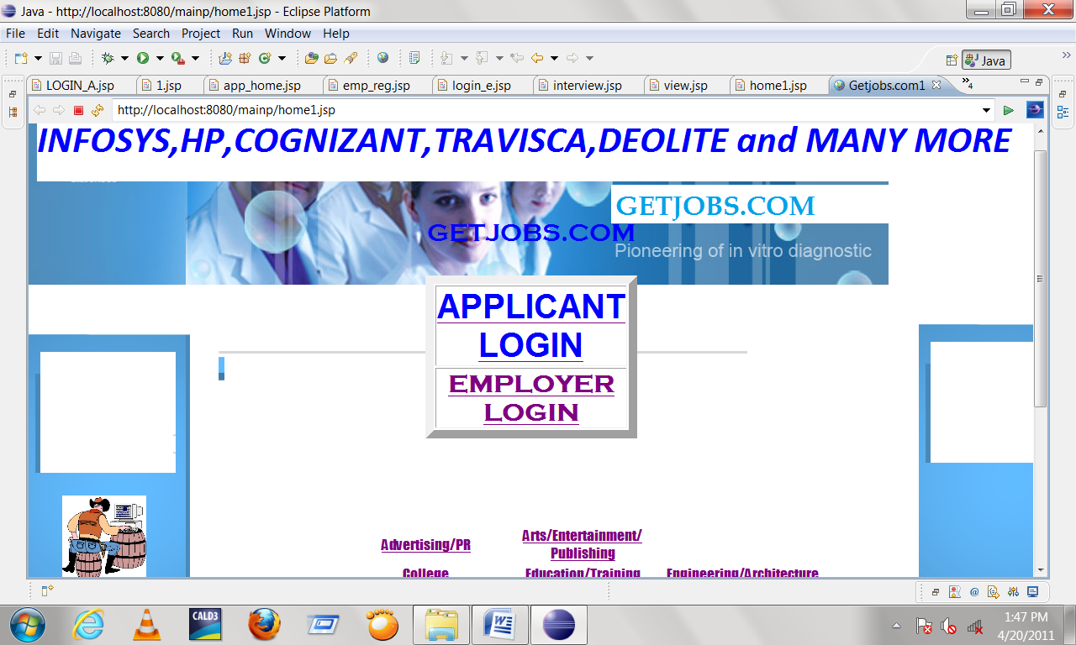

2.LOGIN PAGE

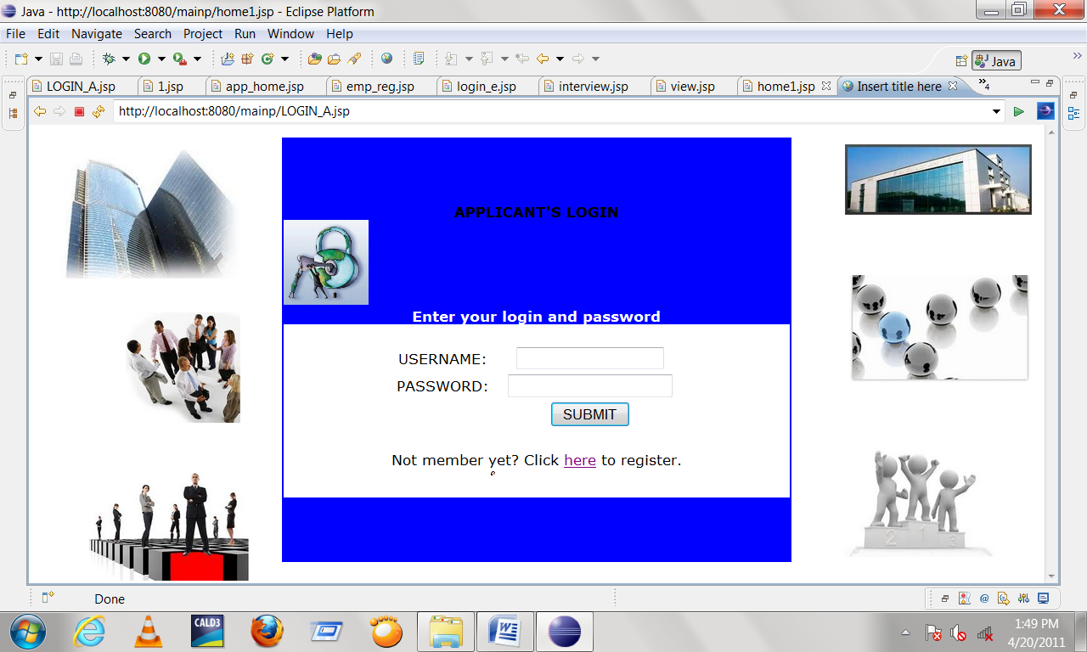

3.CANDIDATE’S HOME PAGE

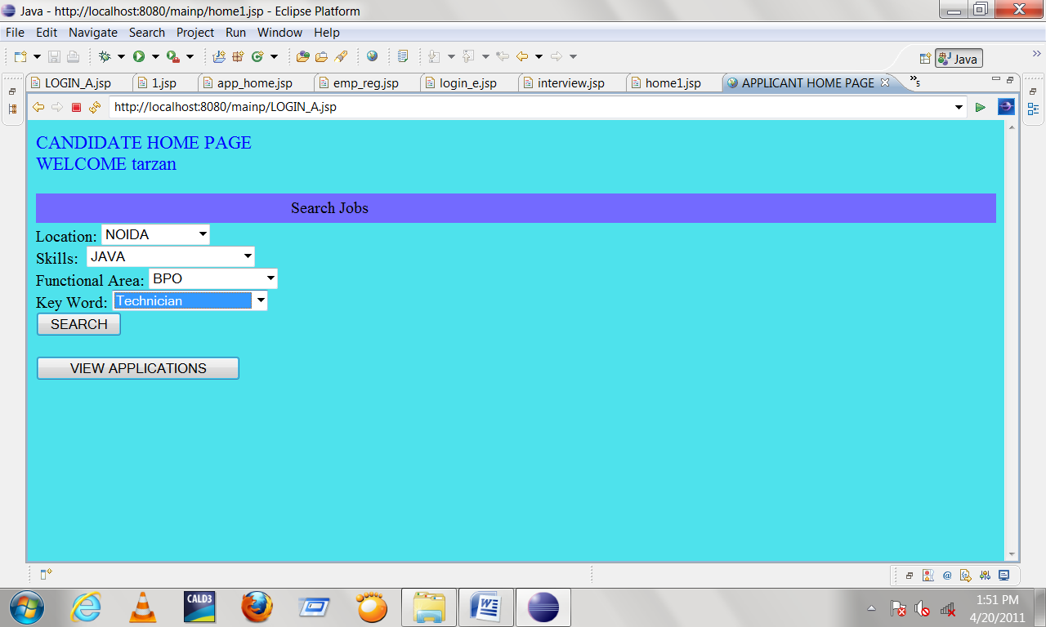

4.INTERVIEW PAGE

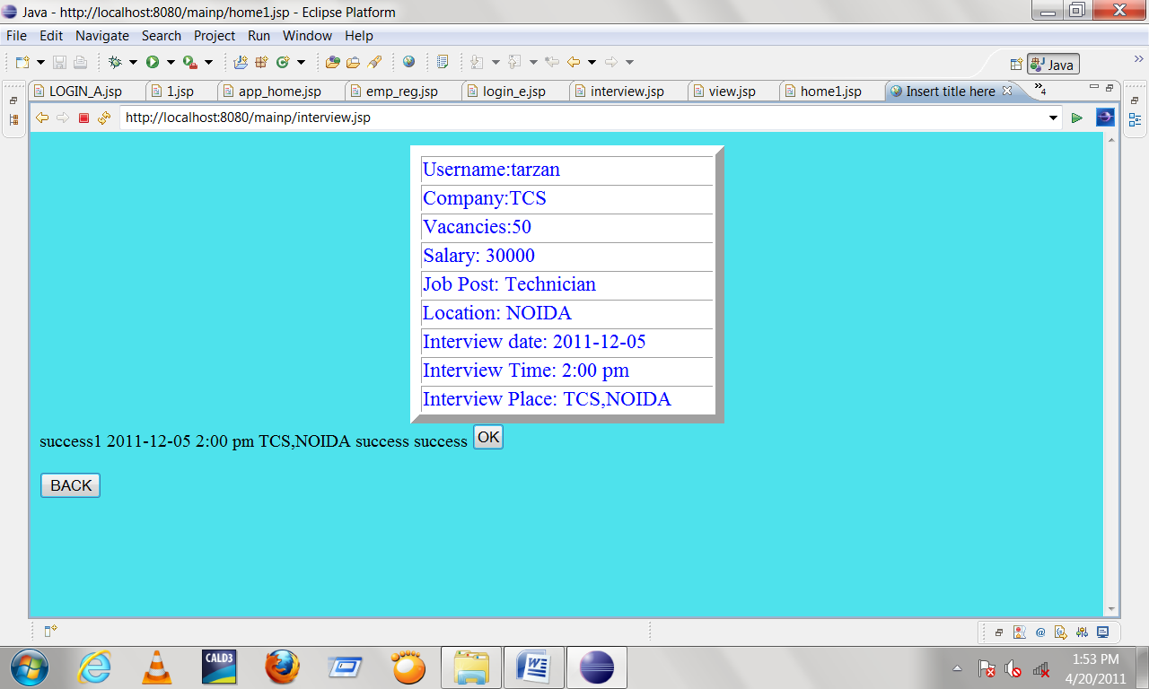

5.CANDIDATE’S REGISTRATION PAGE

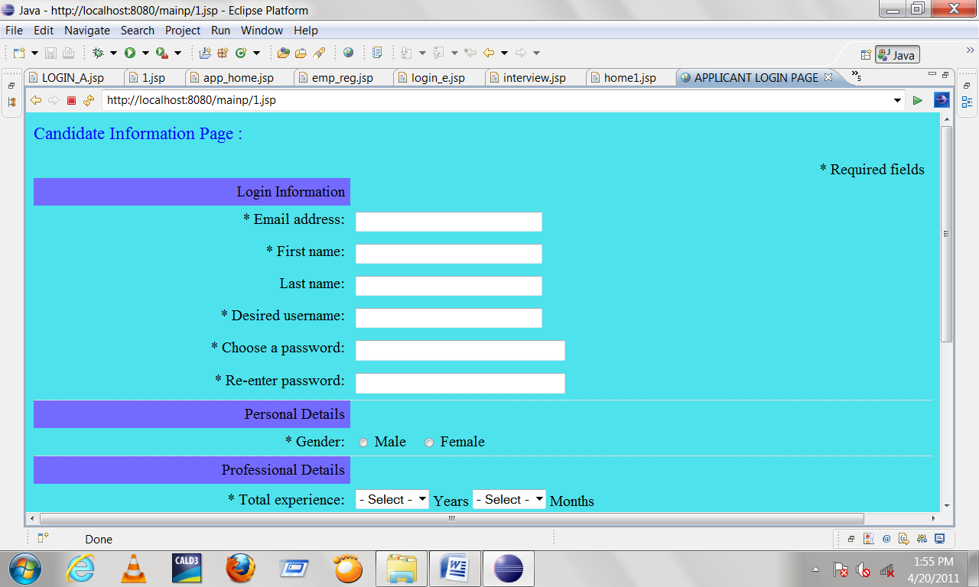

FUTURE SCOPE

There have been numerous cases of computer glitches, errors in content, and security lapses reported in online job searching .So in the near future the so –called software could be made more secure and reliable.While electronic glitches are rare, they have been known to occur, for instance when computer crashes voided the efforts of thousands of student. There are also cases in which the correction software has corrupted databas. so the software can be programmed well so as to avoid corrupted information

CONCLUSION

The Online job portal System is developed using java and sql fully meets the objectives of the system for which it has been developed. The system is operated at a high level of efficiency and all the job seekers and user associated with the system understands its advantage. The system solves the problem. It was intended to solve as requirement specification.

